UCM Compliance Week Scavenger Hunt
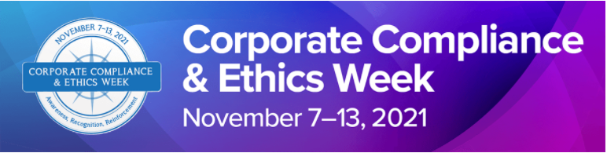
Instructions: Copy and paste the hyperlink for the various Compliance and Information Security/Privacy website items below. Return completed forms to compliance@bsd.uchicago.edu by end of day Friday November 13th. Two winners will randomly be chosen to receive their choice of a $30 Door Dash or Uber Eats e-gift certificate.
Compliance Website: https://compliance.bsd.uchicago.edu/
Compliance Items | Hyperlink (copy and paste here)
1. Where do you learn about the OCC’s employee screening process to check if someone has been excluded from participating in a federal healthcare program?
2. Where can you find the Code of Conduct on OCC’s website?
Bonus: How many “Standards” are in the Code of Conduct?
3. Where can you sign up for Education Sessions?
4. Where can you find our Vendor Relationship policy which guides our workforce on avoiding Conflict of Interest with vendors?
5. Where can you find Office of Corporate Compliance’s guidance documents?

Information Security and Privacy Website: https://home.uchicagomedicine.org/sites/information-security-office
Privacy Items | Hyperlink (copy and paste here)
1. Where can you locate the general patient authorization document? (several answers are correct)
2. Where can you find the Privacy Program guidance documents?
3. Where can you find the HIPAA Privacy Policies?
4. Where can you find the HIPAA Security Policies?
5. In which ways can you report a privacy or security incident/concern? (several answers are correct)

